CREATION OF PRODUCT & CATEGORY TABLE

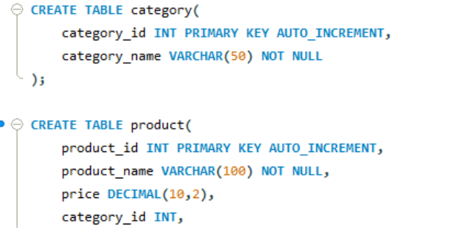
SAMPLE PRODUCT DATA

INSERT INTO category(category_name) VALUES
('Notebook'),
('Pen’),
('Pencil box'),
('Highlighter');

INSERT INTO product(product_name,price,category_id) VALUES
1 | Notebook | 80.00 | 1
2 | Pen | 20.00 | 1
3 | Pencil Box | 120.00 | 1
4 | Highlighter | 50.00 | 1
5 | Eraser | 10.00 | 1
6 | Stapler | 150.00 | 1
7 | Sticky Notes | 60.00 | 1
8 | Study Desk | 4500.00 | 2
9 | Office Chair | 3200.00 | 2
10 | Bookshelf | 2800.00 | 2
11 | Lamp | 900.00 | 2
12 | Potato Chips | 40.00 | 3
13 | Biscuits | 30.00 | 3
14 | Chocolate Bar | 70.00 | 3
15 | Sandals | 800.00 | 4
16 | Sneakers | 2200.00 | 4
17 | Slippers | 400.00 | 4
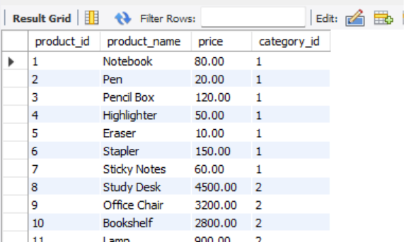
CRUD OPERATIONS
CREATE
INSERT INTO product(product_name,price,category_id)
VALUES('Tablet',18000,1);
READ
SELECT * FROM product;
UPDATE
UPDATE product
SET price=20000
WHERE product_id=18;
DELETE
DELETE FROM product
WHERE product_id=18;

Category-wise Product Analysis Report

Display Products and Their Categories
SELECT p.product_id,p.product_name,p.price,c.category_name
FROM product p
JOIN category c
ON p.category_id=c.category_id;
Count Number of Products in Each Category
SELECT c.category_name,COUNT(p.product_id) AS product_count
FROM category c
LEFT JOIN product p
ON c.category_id=p.category_id
GROUP BY c.category_id,c.category_name;

Find Highest-Priced Product in Each Category
SELECT c.category_name,p.product_name,p.price
FROM category c
JOIN product p
ON c.category_id=p.category_id
WHERE p.price=(
SELECT MAX(p2.price)
FROM product p2
WHERE p2.category_id=p.category_id
);

Display Categories Having More Than 5 Products
SELECT c.category_name,COUNT(p.product_id) AS product_count
FROM category c
JOIN product p
ON c.category_id=p.category_id
GROUP BY c.category_id,c.category_name
HAVING COUNT(p.product_id)>5;

Average Product Price Category-wise
SELECT c.category_name,AVG(p.price) AS average_price
FROM category c
JOIN product p
ON c.category_id=p.category_id
GROUP BY c.category_id,c.category_name;

